Software Design Document – KPT Tracker

1. Overview - provide an overview and scope 2

1.1 Purpose - explain what the software will do (or not do) 2

1.2 Stakeholders - who is this document intended for 2

1.3 References - provide a complete list of documents 2

1.4 Overview - outline what the SDD contains 2

2. Document version - example 3

3. Design decision - example 3

3.1 Building development of application 3

3.2 Application/case/class diagram 3

3.3 Event Flow diagram 4

4. Constraints - example (only if required) 5

5. Risk Assessment 5

5.1 Risk Assessment 5

5.2 Risk mitigation 5

6. Estimation - example (optional) 6

6.1 Project Estimation 6

7. Test Cases - example 6

7.1 Unit Test Case 7

7.2 Integration Test 7

7.3 UI Test Case 7

7.4 User Acceptance Test/Usability Test 7

8. Sign-Off 8

# Overview - provide an overview and scope

## Purpose - explain what the software will do (or not do)

This project is to develop a KPI tracker application that calculates the completed cases percentage of cases based on the number of closed cases versus assigned cases. The application main purpose is to provide a quick and efficient alternative to the service desk software's reporting process.

## Stakeholders - who is this document intended for

* Academy IT Consulting Services (AIT-CS)
* Service Desk Analysts (SDAs)
* Development team
* Project manager

## References - provide a complete list of documents.

Add any documentation links here including but not limited to:

* Requirements document
* Design standards
* Client documents

## Overview - outline what the SDD contains

1. Overview
2. Document versions
3. Design decisions
4. Test Cases
5. Constraints
6. Time estimate

# 

# Document version - example

|  |  |  |
| --- | --- | --- |
| **Name** | **Section** | **Date** |
| John Smit | Test Cases | Sep 5, 2021 |
|  |  |  |

# Design decision - example

## Building development of application

The application will be built using the Python programming language with a graphical user interface (GUI) library for user interaction and display of results.

## Application/case/class diagram

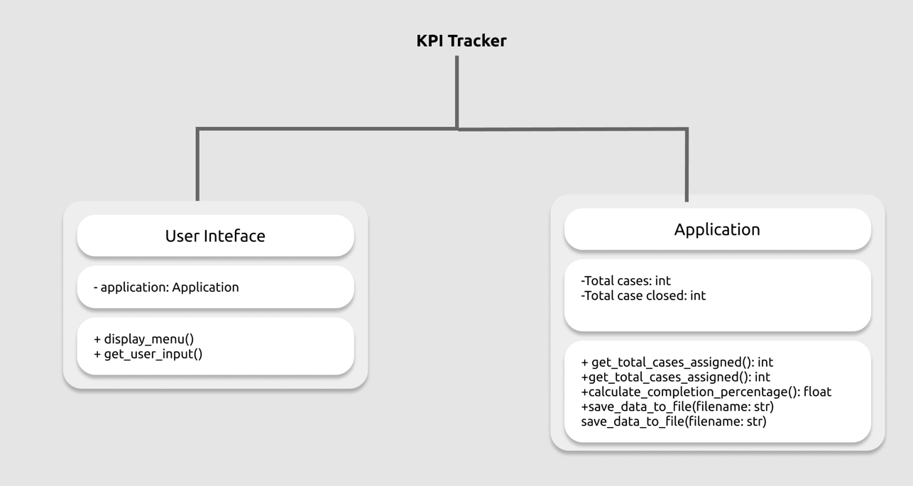

## Event Flow diagram

### 

Display The Result

Start application.

Users enter the input.

Calculating the percentage.

Store data in text File

# Constraints - example (only if required)

Describe any foreseeable design issues or blockers e.g.

* Need updated software/tools (do we need to update any tools or software?)
* Hardware constraints (can the hardware host or deploy this application?)
* Resourcing constraints (do we have the manpower?)

# Risk Assessment

## Risk Assessment

* Data input errors may result in inaccurate completion percentage.
* Inadequate testing may lead to undiscovered bugs or functionality issues.
* Lack of user training may cause difficulties in navigating and using the application.

## Risk mitigation

* Implement input validation to ensure accurate data entry.
* Conduct thorough testing, including unit tests, integration tests, UI tests, and user acceptance tests.
* Provide user training and documentation to ensure ease of use.

# Estimation - example (optional)

## Project Estimation

| Task | Description | Effort - days |
| --- | --- | --- |
| Create code | Takes user input and parses to application and produces an output | X |
| Debug code | Debug and rectify code errors |  |
| Create application | Checks input from user and display correct information | X |
| Testing | Run test cases | X |

# Test Cases - example

Test Case Example 1: Application displays required output

| **Step** | **Description** | **Expected Result** | **Actual Result** | **Pass/Fail** |
| --- | --- | --- | --- | --- |
| 1. | User can start application | Application runs |  | ✅/❌ |
|  | User enters “Hello World” |  |  |  |
|  |  | “Hello World” displayed |  | ✅/❌ |

Test Case Example 2: Application does not display required output

| **Step** | **Description** | **Expected Result** | **Actual Result** | **Pass/Fail** |
| --- | --- | --- | --- | --- |
| 1. | User can start application | Application runs |  | ✅/❌ |
|  | User enters “Hellow World” |  |  |  |
|  |  | “Hellow World” displayed |  | ✅/❌ |
| 2. | Error message displays | “Error: Incorrect spelling” |  |  |
| 3. | User given a choice to leave program | Exit ? (yes/no) |  | ✅/❌ |

## Unit Test Case

## Integration Test

## UI Test Case

## User Acceptance Test/Usability Test

# Sign-Off

|  |  |
| --- | --- |
| **CLIENT ACCEPTANCE FORM** | |
| The client acceptance form indicates complete acceptance, by the client, of the outlined deliverables and confirms that the design phase requirements have been completed. | |
| Project Name | KPI Tracker |
| Client | Antony |
| Project Manager | Charles |
| **DELIVERABLES COMPLETED** | |
| Deliverables |  |
| Acceptance Response | Accepted  Not Accepted until below issues are addressed  Accepted provided below issues are addressed |
| Issues |  |
| Remarks |  |
| **SIGN OFF** | |
| Project Manager |  |
| (name) (signature) (date) |
| CIO |  |
| (name) (signature) (date) |
| CEO |  |
| (name) (signature) (date) |
| CFO |  |
| (name) (signature) (date) |